How to use filter activity after get meta data activity

How to copy the current date files in the get meta data activity and filter activity

1. Create datasets and linked lists as previously
2. Then go to get meta data activity
3. Go to settings add dataset in field list add child items

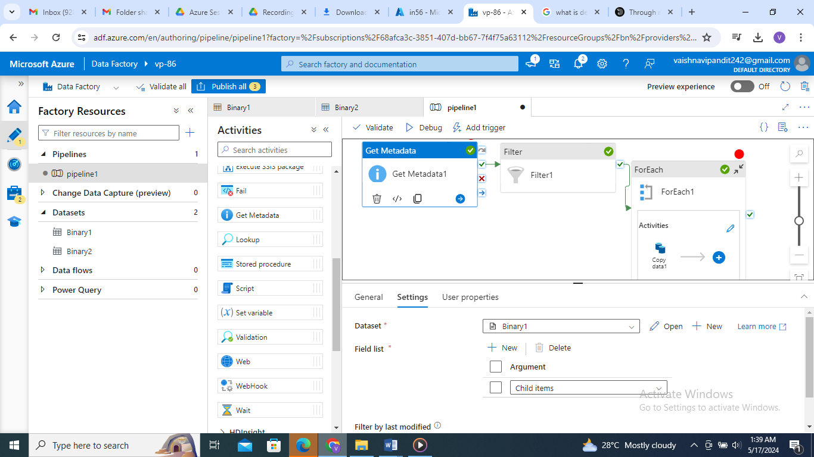

1. Then create filter activity from the conditions and iteration section then

In items select add dynamic contents and add get meta data activity and in condition select the conatains then items and then write .name then , filterdate(utnow(),ddMMyyyy)

Like@contains(items.name, filterdate(utnow(),ddMMyyyy)

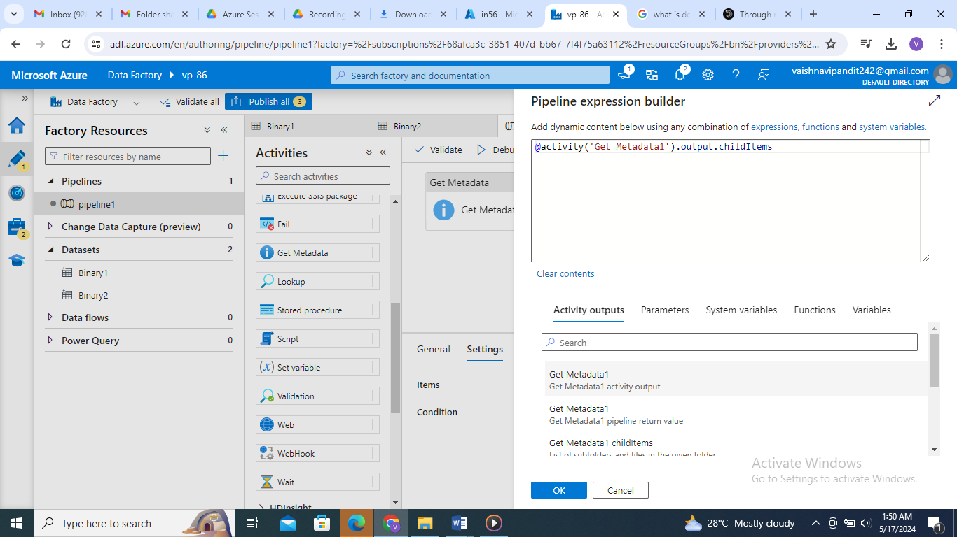

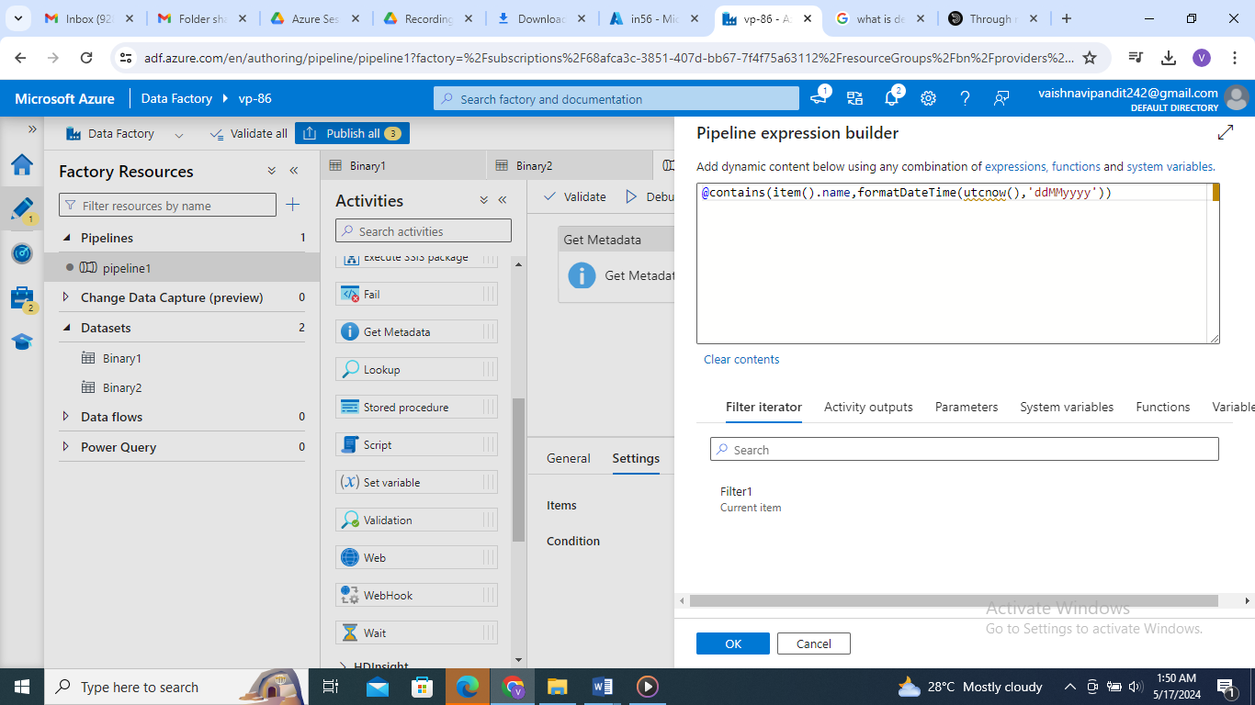

1. Then select for each activity in for each activity in items select filter output and then put .value after it it is very much important as the data is in object form and we require it in array form.

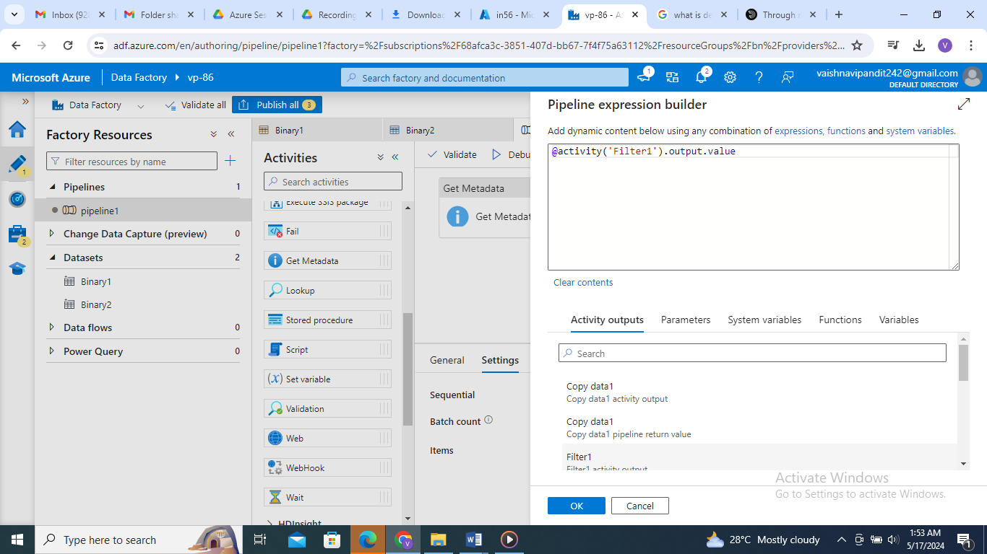

1. Then do the copy activity similary as previously inside the for each activity.